**How to Build the Dementia Friendly Music Player**

**Deluxe Model – Has Built-in Speakers that Auto Mute With Headphones**

15 January 2021, [http://DementiaMusicPlayer.org](http://dementiamusicplayer.org/), Ross Porter [rosswesleyporter@gmail.com](mailto:rosswesleyporter@gmail.com)

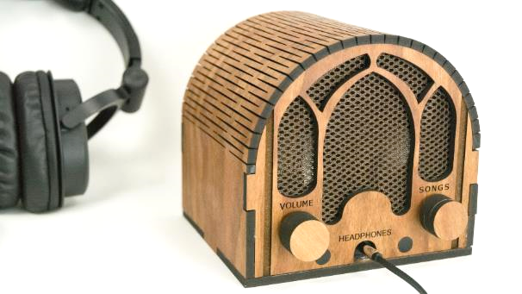  
  
My Dad could not operate normal music players. But he could operate this music player because it operates like a familiar two-knob radio. My son & I were inspired to design this by the documentary [Alive Inside](http://www.aliveinside.us/#land) which shows the profound joy felt by some people with dementia when listening to their favorite music.

It’s easier than you think to make one. Everything I did (e.g. software, wood case design) is open source. This document contains all the information you need. You can order the parts online. Good project for kids. A 13 year old can do this with minimal assistance. Younger kids with more assistance.



|  |  |
| --- | --- |
| **Parts cost** | ~$235 + tax + shipping  (~$120 if make 10 or more at a time, see Appendix 1) |
| **Music cost** | Minimal as you should use the recipient’s existing music collection |
| **Build time** | About six hours, once you have the parts & music |
| **Parts source** | All parts can be mail ordered, links below |
| **Soldering?** | No |
| **Woodworking?** | No |
| **Laser cutter needed?** | No, you can mail order the pre-cut pieces for the wood case |
| **With a friend?** | Good idea, especially if your friend has the basic tools required |
| **Beverage?** | I recommend a hoppy IPA while you are assembling |

|  |  |
| --- | --- |
|  |  |

# Preview of the steps

|  |  |  |
| --- | --- | --- |
| **Order parts** | **Order the case** | **Assemble recipient’s favorite music**  Complete Beethoven Edition, Vol. 1: Symphonies |
| **Copy software to micro SD card**  http://ecx.images-amazon.com/images/I/71sgCaQGpKL._SL1500_.jpg | **Add the Pi** | **Test it** |
| **Glue it** | **Wire it** | **STEP 9: Enjoy!** |

# No warranty

USE THESE DQMUSICBOX PLANS AND SYSTEM AT YOUR OWN RISK. THE DQMUSICBOX PLANS ARE PROVIDED AS IS WITHOUT WARRANTY OF ANY KIND EITHER EXPRESSED OR IMPLIED, INCLUDING, BUT NOT LIMITED TO, THE IMPLIED WARRANTIES OF MERCHANTABILITY AND FITNESS FOR A PARTICULAR PURPOSE. THE ENTIRE RISK AS TO THE QUALITY AND PERFORMANCE OF THE PLANS AND SYSTEM IS WITH YOU. SHOULD THE PLANS OR SYSTEM PROVE DEFECTIVE, YOU ASSUME THE COST OF ALL NECESSARY SERVICING, REPAIR OR CORRECTION. IN NO EVENT WILL ANY PARTY BE LIABLE TO YOU FOR DAMAGES, INCLUDING ANY GENERAL, SPECIAL, INCIDENTAL OR CONSEQUENTIAL DAMAGES ARISING OUT OF THE USE OR INABILITY TO USE THE PLANS OR SYSTEM.

# Acknowledgements

People were very generous with their time, and I really enjoyed the experience. This is certainly an incomplete list: Alex & Mike & others at [Ada’s](http://blog.seattletechnicalbooks.com/), the super smart staff at [Metrix](http://www.metrixcreatespace.com/), neighbor Randy, [Stephen Christopher Phillips](http://scphillips.com/), [Bob Rathbone](http://www.bobrathbone.com/), [Stephen Rusk](http://www.stephenrusk.com/), [Graham Hill](http://www.ted.com/speakers/graham_hill), support at [Ponoko](https://www.ponoko.com/), [Florian Festi](https://www.festi.info/boxes.py/index.html), and my son.

# How it works

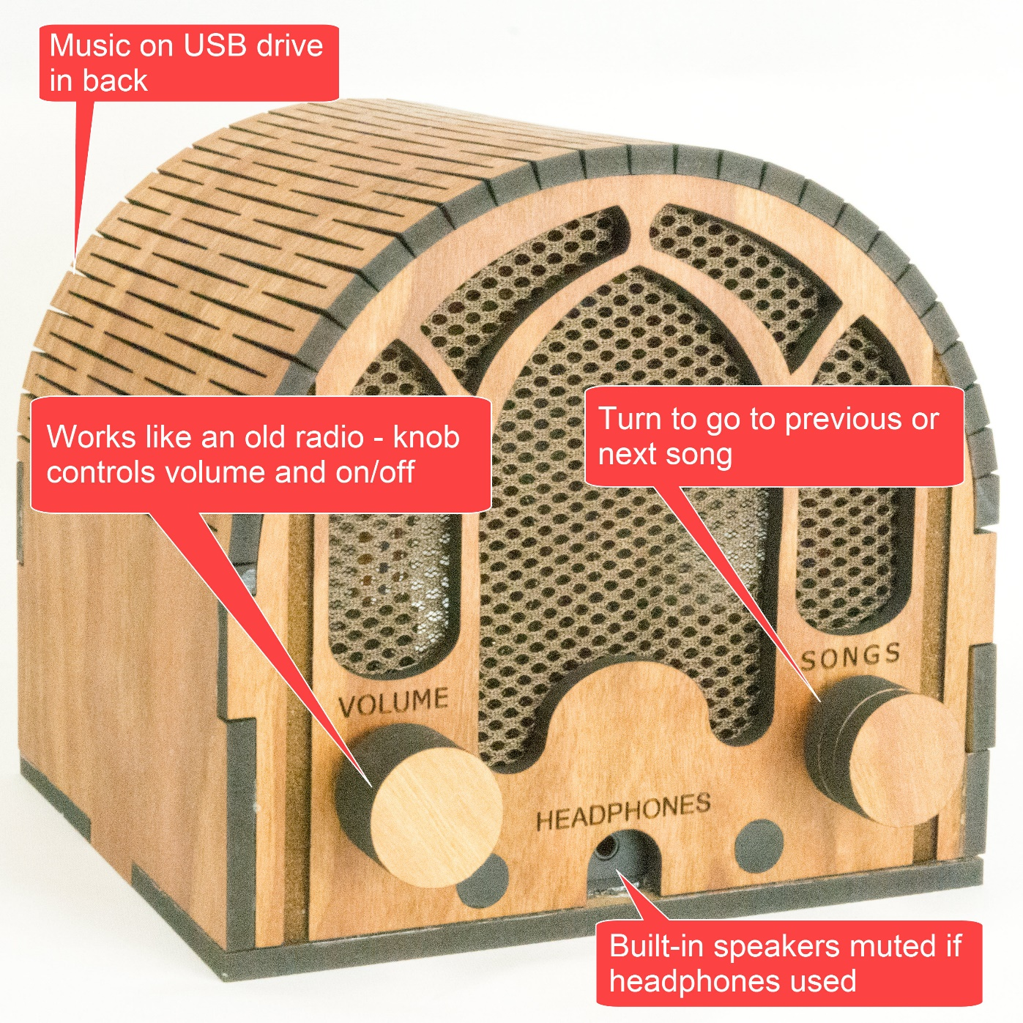

# STEP 1: Order or make the case

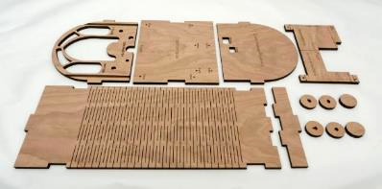

## Create a Ponoko account (optional but convenient)

Ponoko is a company that laser cuts wood and sends you the precisely cut pieces. You don’t need to use Ponoko – you are welcome to download my case design files from [github](https://github.com/rosswesleyporter/dqmusicbox/tree/master/case/deluxe_model) and go to your local maker space and use the laser cutter there. Or buy yourself a laser cutter (if you do, will you be my friend?). In other words, Ponoko is convenient but not necessary. I have no affiliation with them, other than being a happy customer. To create a Ponoko account:

1. Go to <https://www.ponoko.com/>
2. Choose “Get Making”

## Order from Ponoko

1. Go to <https://drive.google.com/drive/u/0/folders/1R8kW8P6VqMwA4OXFMg3WZg5pHoADic-Y>
2. Right-click on DementiaFriendlyMusicPlayer_Deluxe_5point2mm_PONOKO.svg, choose “Save link as…”
3. Go to <https://www.ponoko.com/>
4. Login
5. If prompted in blue at the top of the screen, choose to switch to Ponoko 5.0
6. Click on “Reorder” and/or click on “Make your first product”
7. Choose wood, Cherry Veneer MDF
8. Choose “Upload your design” and upload the file that you downloaded just above, wait while Ponoko validates the design
9. Then set design colors as below, and click “Confirm design size & colors”   
   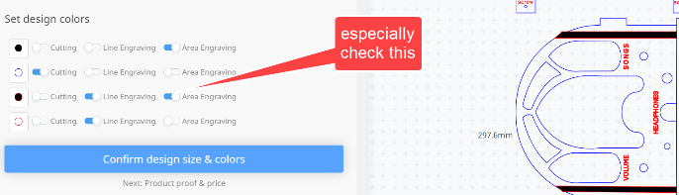
10. Click “Add to Cart”

# STEP 2: Order the parts

If you plan to make 10+ units at a time, see Appendix 1 rather than the table below.

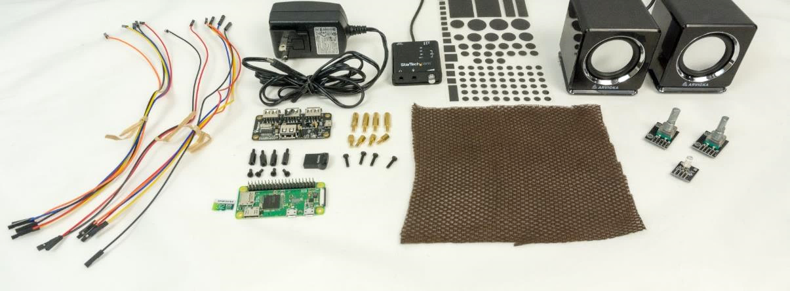

|  |  |  |  |
| --- | --- | --- | --- |
| **Item** | **Supplier** | **Cost** | **Notes & alternatives** |
| Cherry case | Ponoko | $84.77 | See instructions above. |
| [Raspberry Pi Zero WH](https://www.adafruit.com/product/3708) | Adafruit | $14.00 | Or buy PiShop.us SKU 1052 |
| [power supply: 5V 3A, micro-USB](https://www.adafruit.com/product/1995) | Adafruit | $7.50 | Or buy Amazon B00MARDJZ4 |
| [Premium Female/Female Jumper Wires - 40 x 6"](https://www.adafruit.com/product/266) | AdaFruit | $3.95 | Or buy Amazon B07GCY6CH7 |
| [USB hub HAT for Pi Zero](https://www.amazon.com/gp/product/B01IT1TLFQ/ref=oh_aui_detailpage_o01_s00?ie=UTF8&psc=1) | Amazon | $13.99 | Or search for "MakerSpot 4-Port Stackable USB Hub HAT" |
| [USB DAC](https://www.amazon.com/gp/product/B00KGK5I38/ref=ox_sc_saved_title_3?smid=ATVPDKIKX0DER&psc=1) | Amazon | $22.99 | Or Amazon B00F7120TQ |
| [M2.5 standoffs (spacing screws)](https://www.amazon.com/Sutemribor-Female-Spacer-Standoff-Assortment/dp/B075K3QBMX/ref=sr_1_4?ie=UTF8&qid=1544322291&sr=8-4&keywords=M2.5+standoff) | Amazon | $11.99 |  |
| [M2.5 screws length=10mm ThreadPitch=0.45](https://www.amazon.com/Machine-Finish-Phillips-M2-5-0-45-Threaded/dp/B00F33S93E/ref=sr_1_22?rps=1&ie=UTF8&qid=1544398707&sr=8-22&keywords=M2.5+screws+10mm&refinements=p_85%3A2470955011) | Amazon | $6.72 |  |
| [16GB micro SD card](https://www.amazon.com/Kingston-16GB-microSDHC-Adapter-SDCS2/dp/B07YGZHSJS/ref=dp_ob_title_ce?th=1) | Amazon | $4.95 | Or buy Amazon B06XWN9Q99 or other 16GB+ card |
| [USB thumb drive](https://www.amazon.com/gp/product/B077Y149DL/ref=ppx_yo_dt_b_search_asin_title?ie=UTF8&psc=1) | Amazon | $6.34 | Or Amazon B07MDXBT87 or other physically small USB drive |
| [Arvicka speakers](https://www.amazon.com/gp/product/B01KC7WGQQ/ref=oh_aui_search_detailpage?ie=UTF8&psc=1) | Amazon | $19.99 | Other speakers no larger than 56W x 56D x 66H mm per speaker &  take 3.5mm audio jack input & USB power |
| [Speaker cloth](https://www.amazon.com/gp/product/B01HMBKQNA/ref=oh_aui_search_detailpage?ie=UTF8&psc=1) | Amazon | $9.99 |  |
| [Light dimming stickers](https://www.amazon.com/dp/B00CLVEQCO/ref=dp_prsubs_3) | Amazon | $5.69 | Optional, but the status LED is really bright. Or use dark tape. |
| [E6000 adhesive](https://www.amazon.com/E6000-237039-Multipurpose-Adhesive-Black/dp/B00BSB2R7O/ref=sr_1_5?keywords=E6000&qid=1580662690&sr=8-5) | Amazon | $10.99 | Or buy at hobby store cheaper. If you have a crafting friend, they probably have some. |
| [KY-040 rotary encoder knobs](https://www.amazon.com/Tegg-KY-040-Encoder-clickable-Arduino/dp/B07QL6V4WP/ref=sr_1_11?keywords=KY-040&qid=1572122001&sr=8-11) | Amazon | $7.99 | Or Amazon B06XQTHDRR |
| [KY-016 indicator LED](https://www.banggood.com/5Pcs-KY-016-RGB-3-Color-LED-Module-Red-Green-Blue-p-954086.html?rmmds=search&cur_warehouse=CN) | Banggood | $4.27 | ALLOW 3+ WEEKS TO ARRIVE FROM CHINA. Due to COVID, it's hard to find these in the US. You can get it quickly from Amazon B07KJYR8K1, but costs $18. |
| **TOTAL** |  | **$236.12** | Prices will vary. Does not include tax, shipping. |

# STEP 3: Get headphones (optional)

## 

You can just use the built-in speakers. But I recommend also having headphones – more immersive. Most headphones with a 3.5mm plug will work just fine. I tried out a lot of headphones for this project. Here are my suggestions.

|  |  |  |
| --- | --- | --- |
| **Item** | **Cost** | **Notes and alternatives** |
| The recipient’s existing headphone | $0.00 | The best headphones are the headphones that the recipient is already used to. |
| [Monoprice over the ear headphones](https://www.monoprice.com/product?c_id=120&cp_id=12001&cs_id=1082302&p_id=8323&seq=1&format=2) | $15.99 | Amazing sound. |
| [Sony MDR7506](https://www.amazon.com/dp/B000AJIF4E/?tag=thewire06-20&linkCode=xm2&ascsubtag=AgEAAAAAAAAAAAQbAAAAABWh_YcAAAAAV0Crgw) | $79.99 | Amazing sound. Perennial favorite. |

# STEP 4: Gather tools & supplies

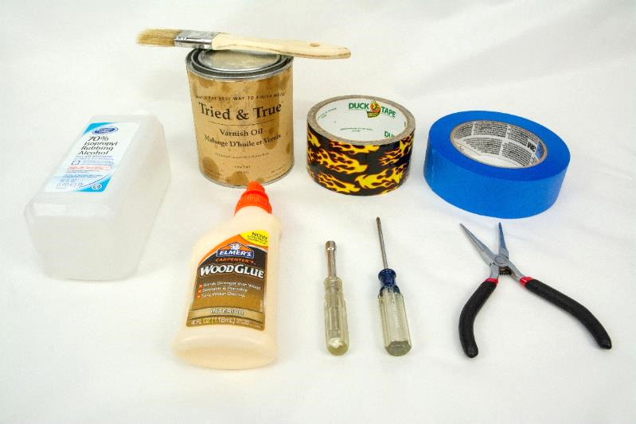

You probably have some of these supplies. If you don’t, you have a friend that does. This is exactly the sort of project that a friend would be happy to help you with.

|  |  |
| --- | --- |
| **Link to order item** | **Notes & alternatives** |
| Isopropyl alcohol | You will use isopropyl alcohol to clean the wood before staining. |
| Wood stain or oil | If you have a friend that does woodworking, ask them for advice and they’ll probably give you the little bit of product that you need. I used [Tried & True Varnish Oil](https://www.amazon.com/gp/product/B003DL10MK/ref=oh_aui_search_asin_title?ie=UTF8&psc=1) (linseed oil) because I like the result, it’s easy, and non-toxic. |
| Brush or cloth |  |
| Duct tape | Any duct tape will do. You will use duct tape as a clamp while gluing. |
| Painter’s tape | Any tape that comes off easily will do. Painter’s tape is great. Regular masking tape is probably fine too. |
| Needle nosed pliers | Handy for grabbing screws that drop into the case and for extracting small USB drives |
| Philips screw driver #0 | #0 i.e. small |
| Elmer’s wood glue | Any wood glue will do |
| 3/16th nut driver | Or wrench. Or needle-nosed pliers. Or really strong fingers |
| SD card reader/writer | Your computer may have an SD card reader/writer. If not, you probably have a friend that does. Or order a [USB SD-card reader](https://www.amazon.com/gp/product/B00OJ5WBUE/ref=oh_aui_search_detailpage?ie=UTF8&psc=1). |

# STEP 5: Assemble the personalized collection of music

## Choosing the music – go for familiar favorites

This is the most important step. The personalized (familiar) music is the fundamental magic. You don’t need much music, perhaps 10 albums. But only familiar favorites. In my case, my Mom mailed me my Dad’s favorite CDs. It will take two weeks for the parts above to arrive, so you have time to do this well. Though it is easy to change the set of music later.

## Put the music on the USB memory stick

Organize the digitized music into folders on the USB memory stick, one folder per album. MP3, iTunes, and FLAC files are supported i.e. files with extensions .mp3, .m4a, .flac. In the end, you should have a set of folders that looks something like this:



# STEP 6: Copy software to the micro-SD memory card

I prepared a disk image for you. It has all the required software. Your job is to download this disk image and then write it to the micro-SD card. The steps:

1. Install [Etcher](https://etcher.io/) on your PC or Mac or Linux computer. [Win32 Disk Imager](http://sourceforge.net/projects/win32diskimager/) also works.
2. Download the [Dementia Friendly Music Player disk image](http://bit.ly/3oTnHKD).
3. Put the micro-SD memory card into the SD card adapter that it came with i.e. put the tiny card into the larger card.
4. Put the SD card adapter into the SD reader/writer in your computer.
5. Start Etcher, instruct it to write the image file to the SD card:  
   
6. Wait for the writing to complete, ~10 minutes. This would be a good time to make a sandwich.

# STEP 7: Stain it or oil it

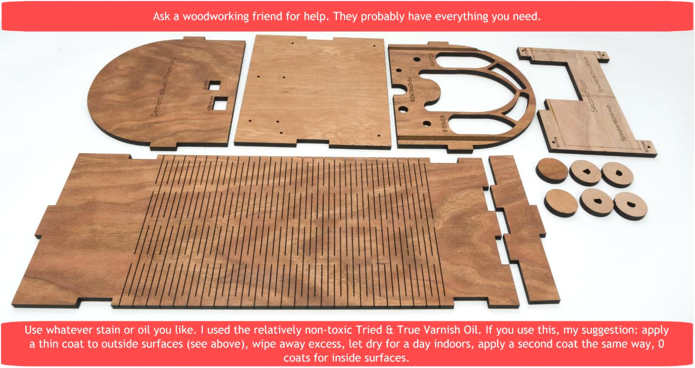

# STEP 8: Add standoffs

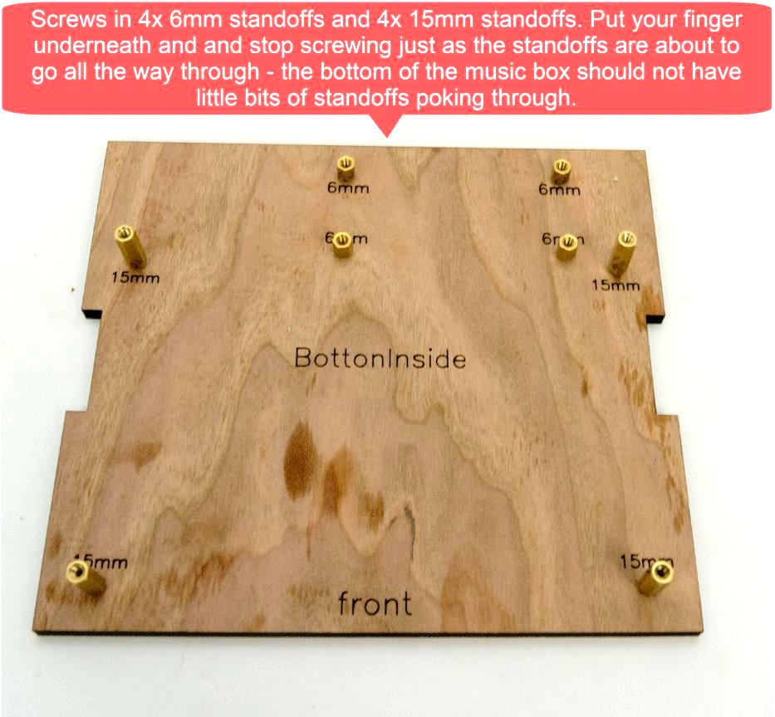

# STEP 9: Adhere the speaker fabric

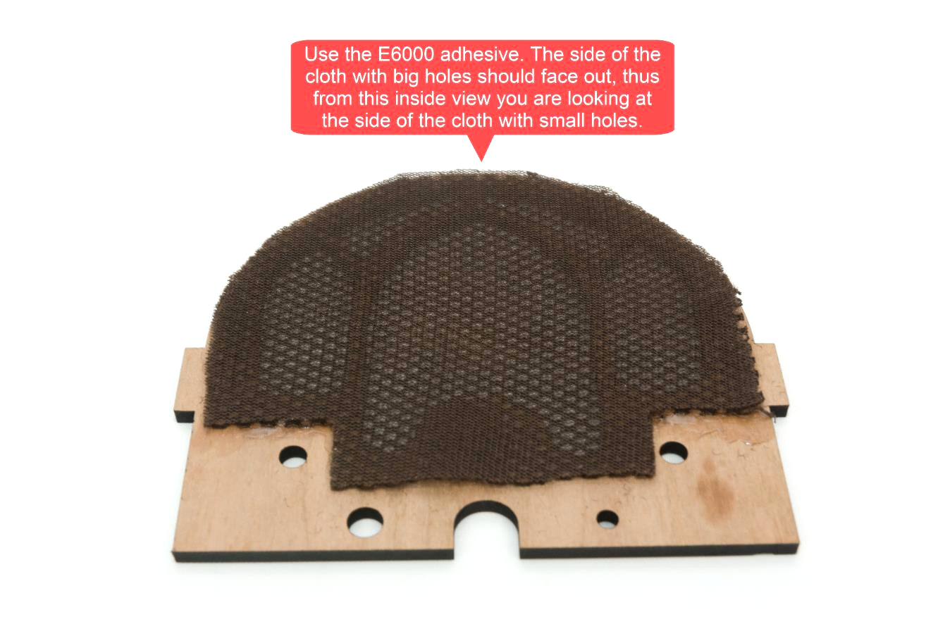

# STEP 10: Add the USB hub

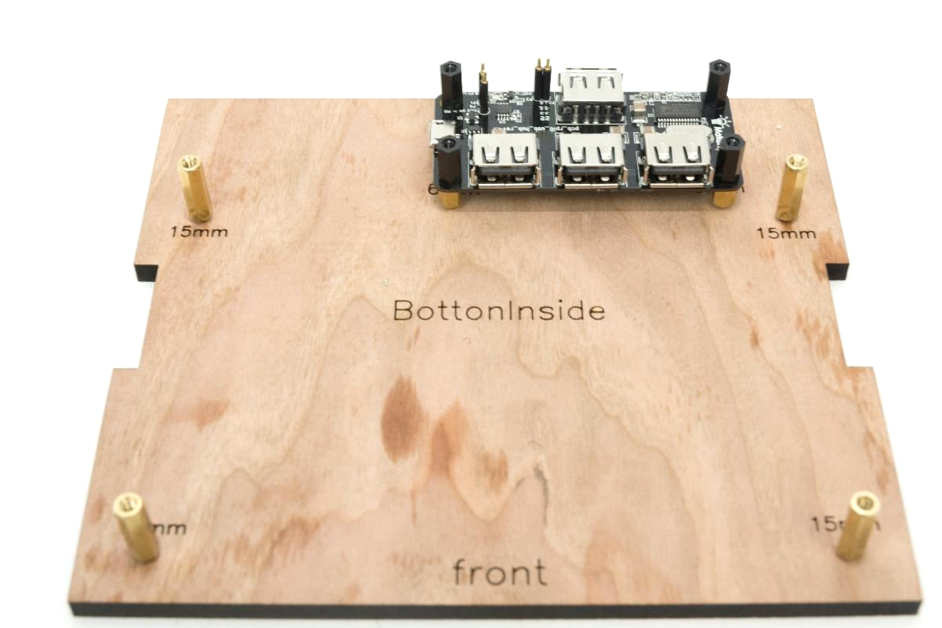

# STEP 11: Make sure the pins are straight

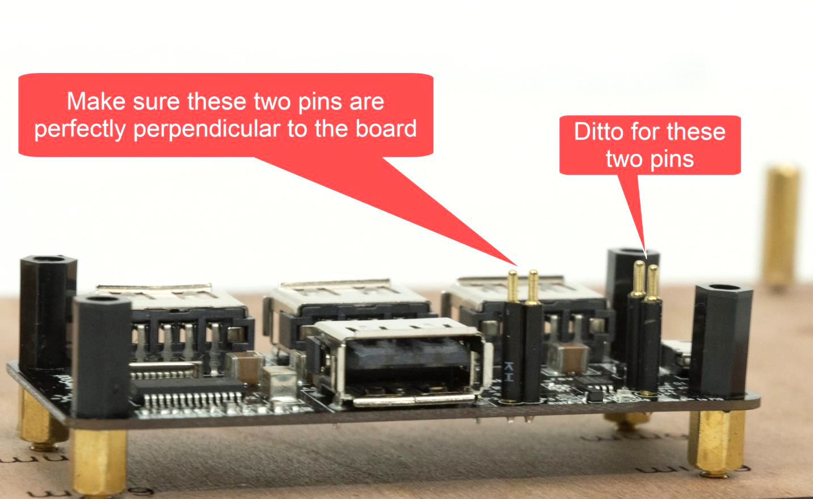

# STEP 12: Loosely attach the Pi

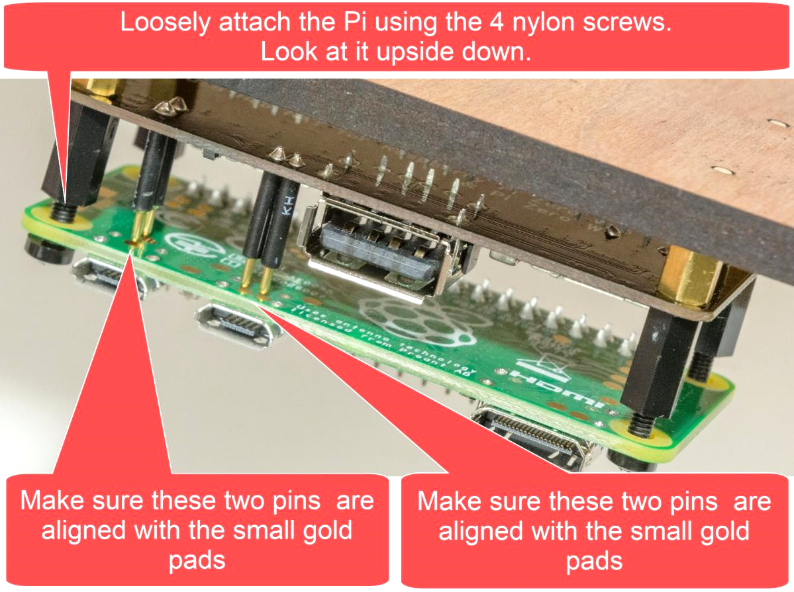

# STEP 13: Firmly attach the Pi

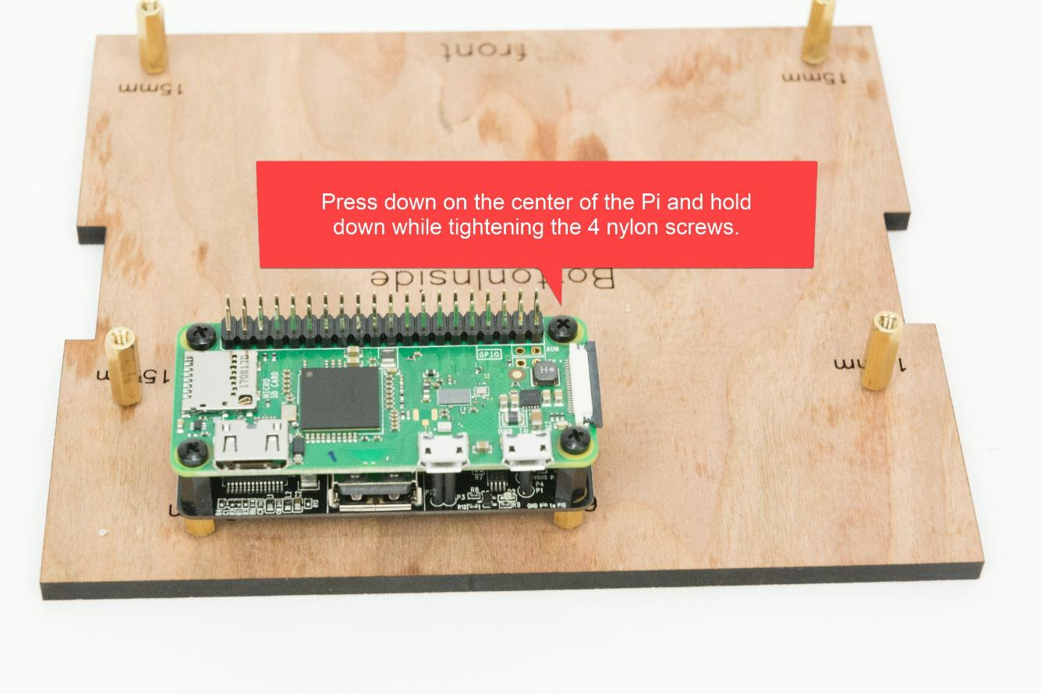

# STEP 14: Test #1

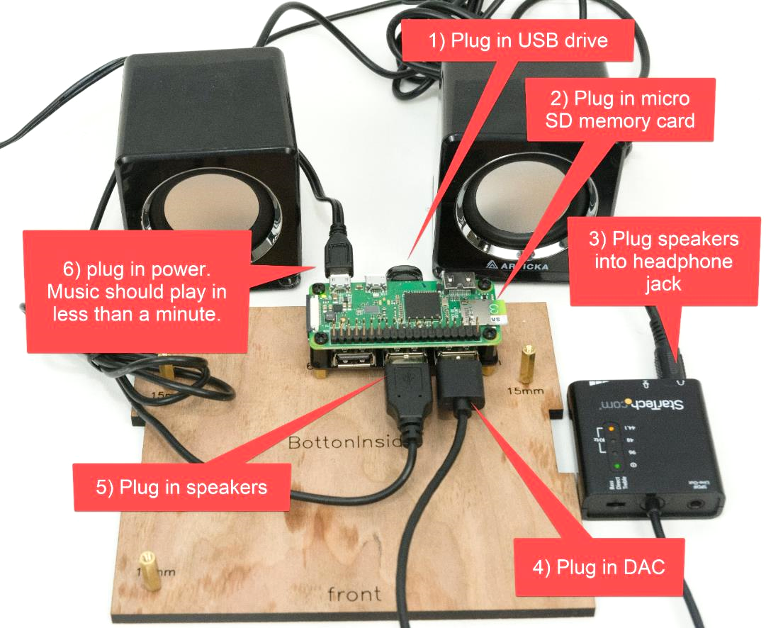

# STEP 15: Adhere the indicator LED

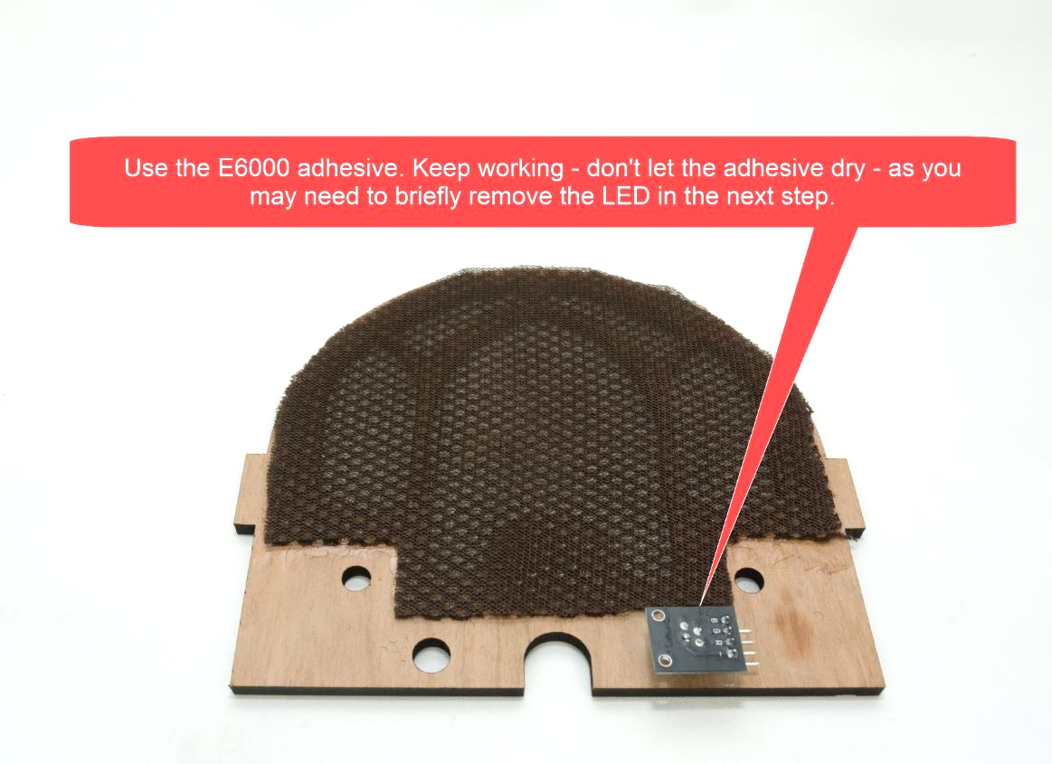

# STEP 16: Screw in rotary encoders

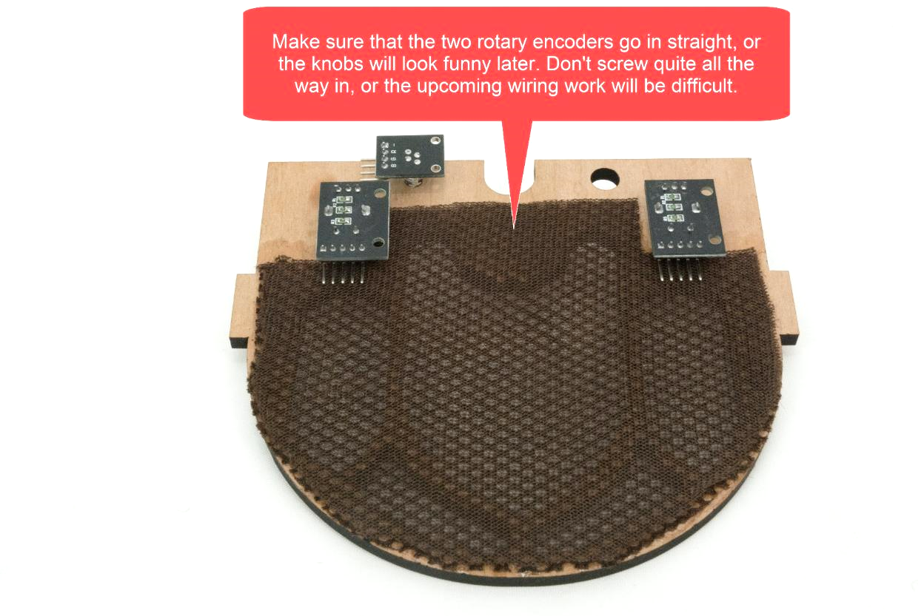

# STEP 17: Wire the front panel components

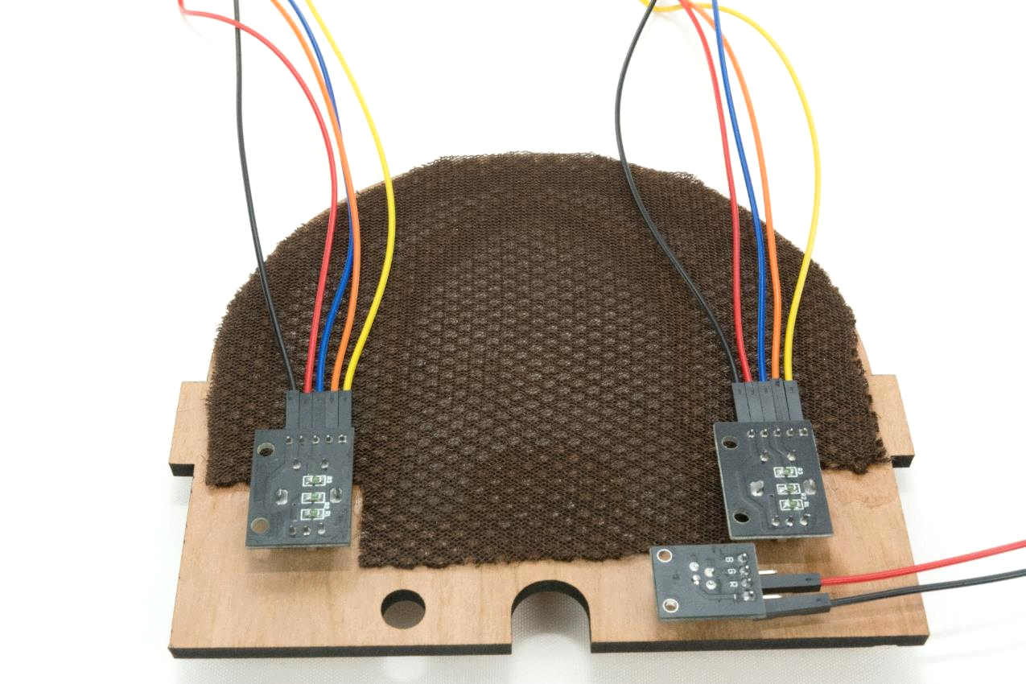

# STEP 18: Add the 2nd floor

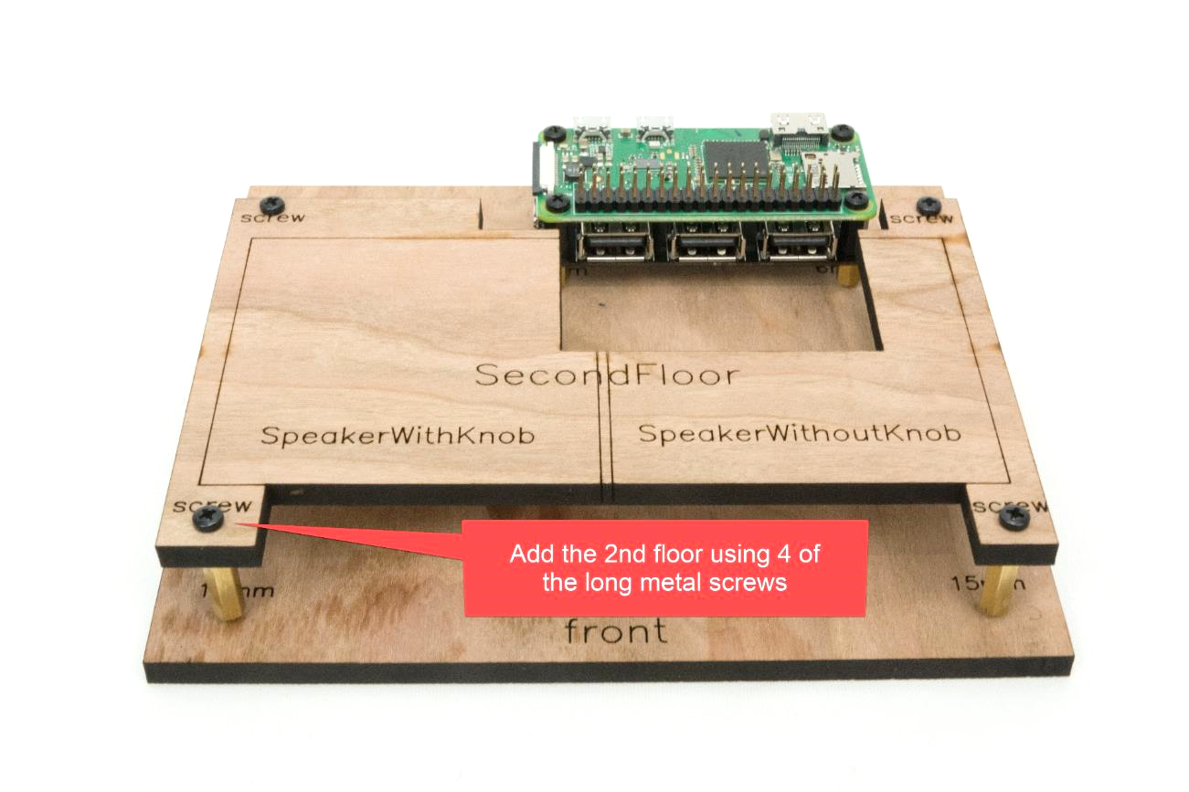

# STEP 19: Review how the wood pieces will fit together

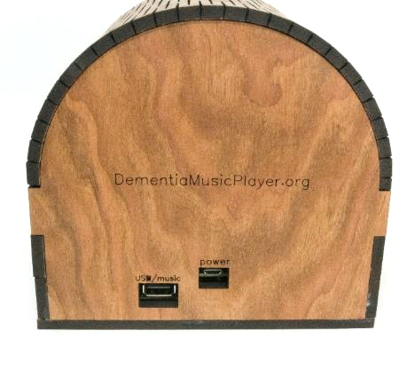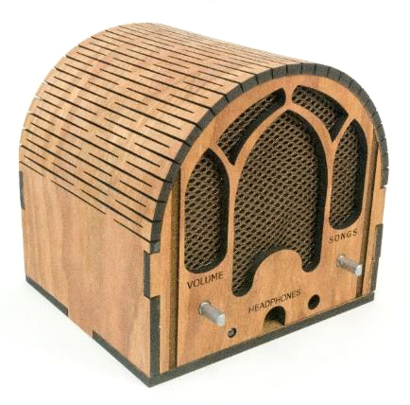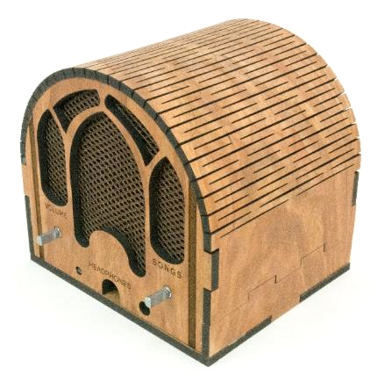

# STEP 20: Apply glue

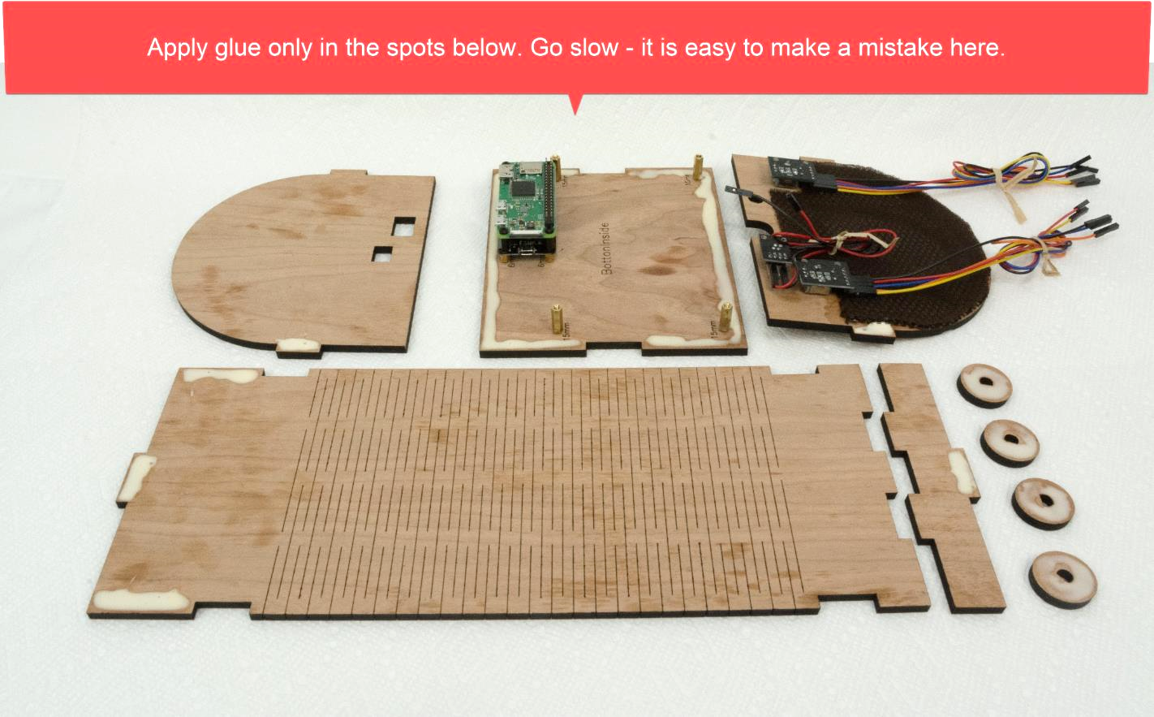

# STEP 21: Clamp it

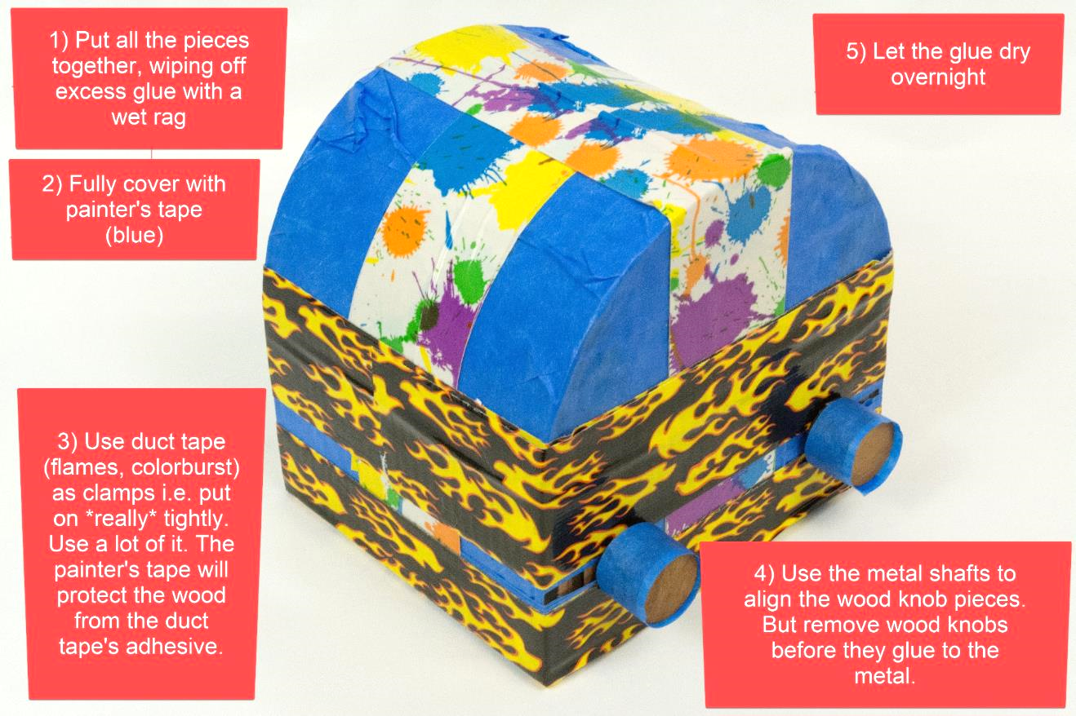

# STEP 22: Adjust knobs if needed

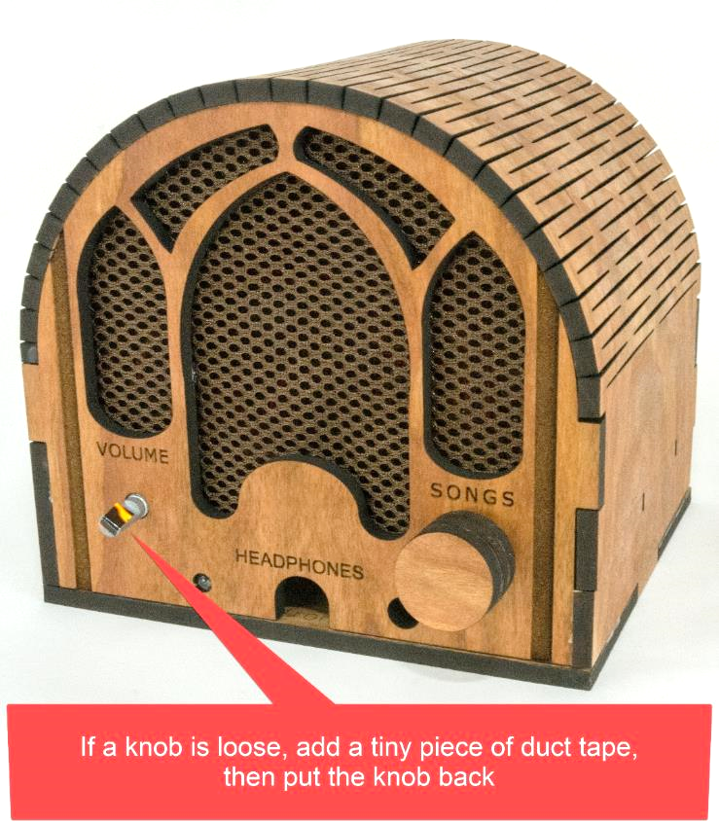

# STEP 23: Create a rig

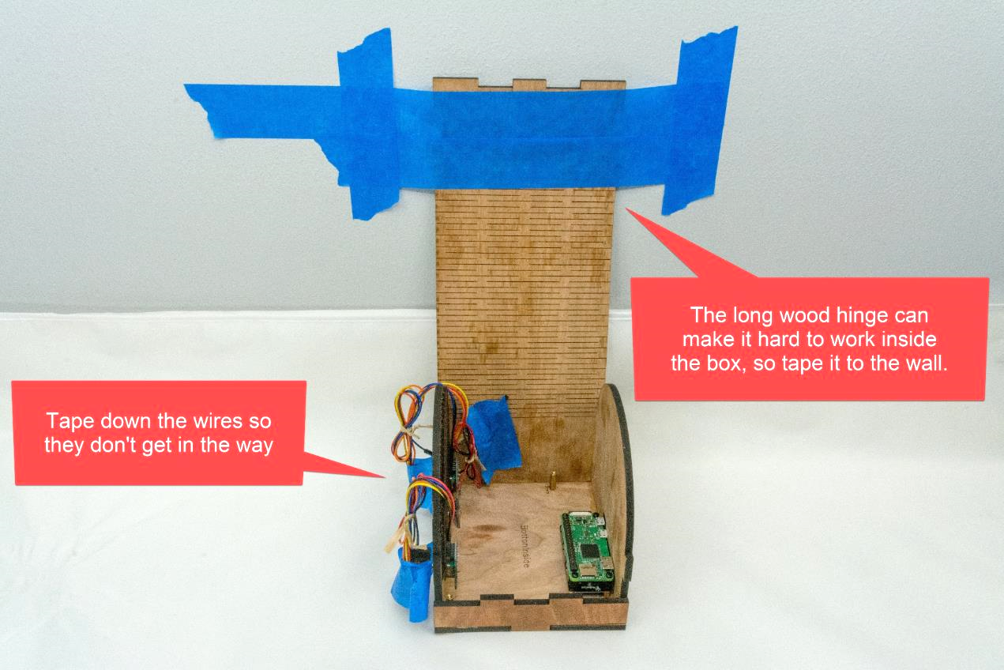

# STEP 24: Plug speakers into line out

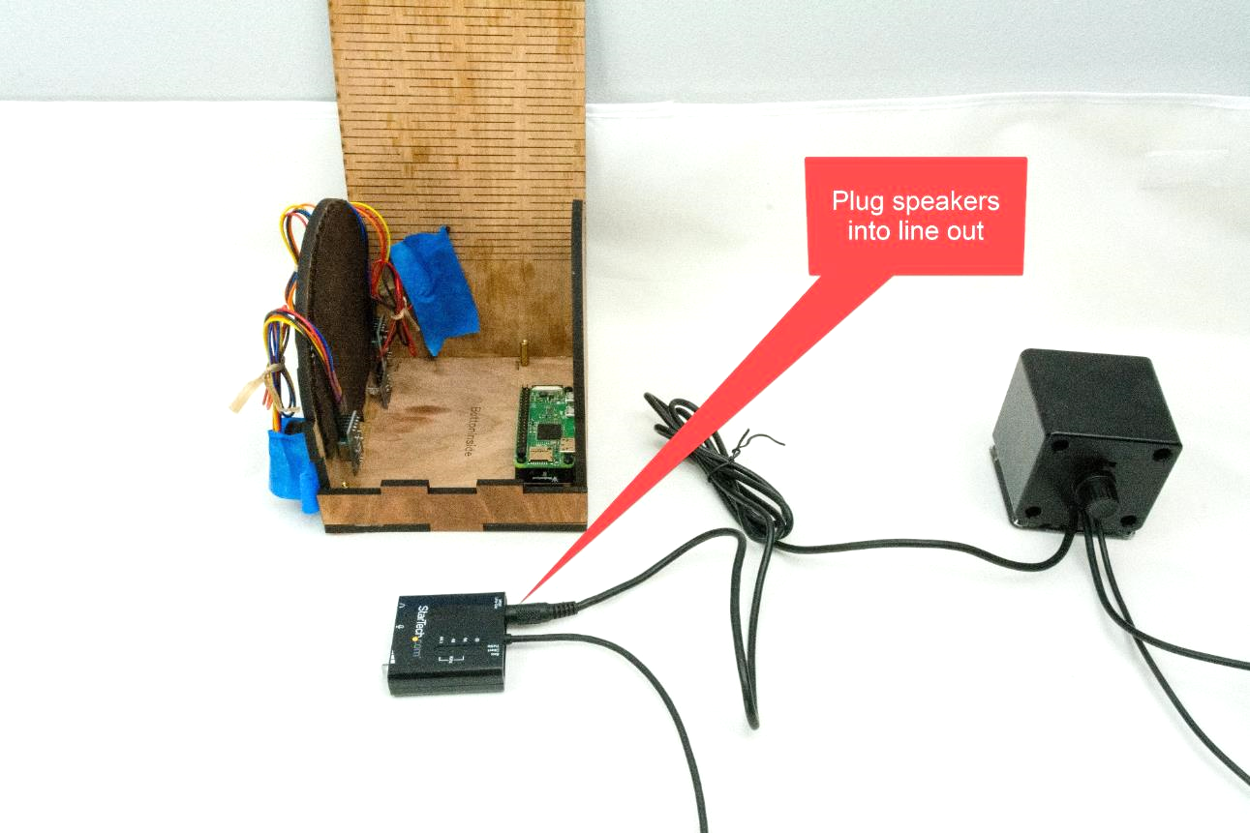

# STEP 25: Adhere the DAC

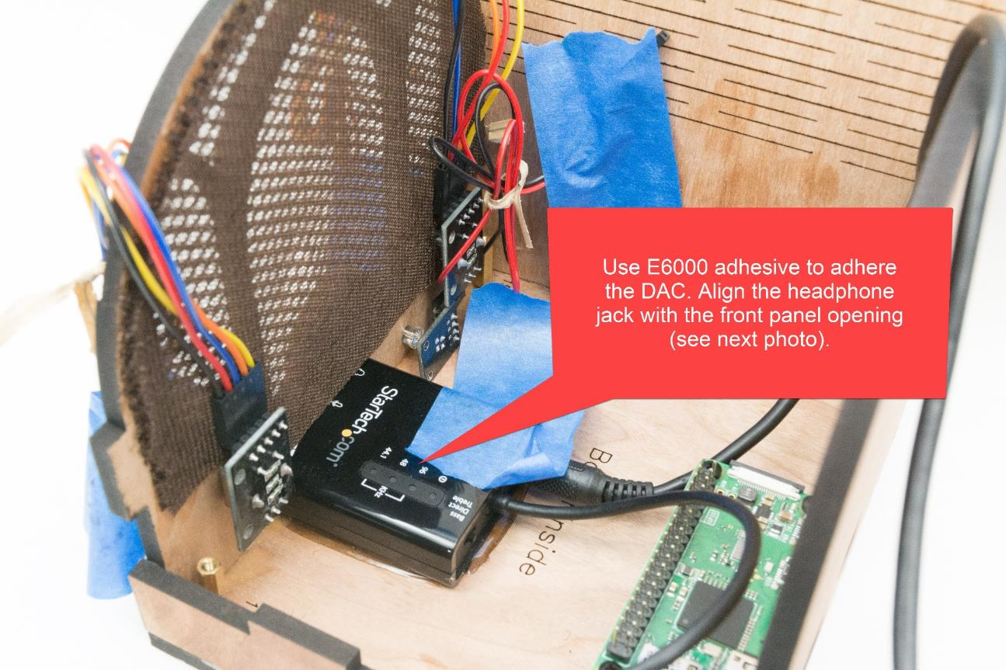

# STEP 26: Check DAC alignment

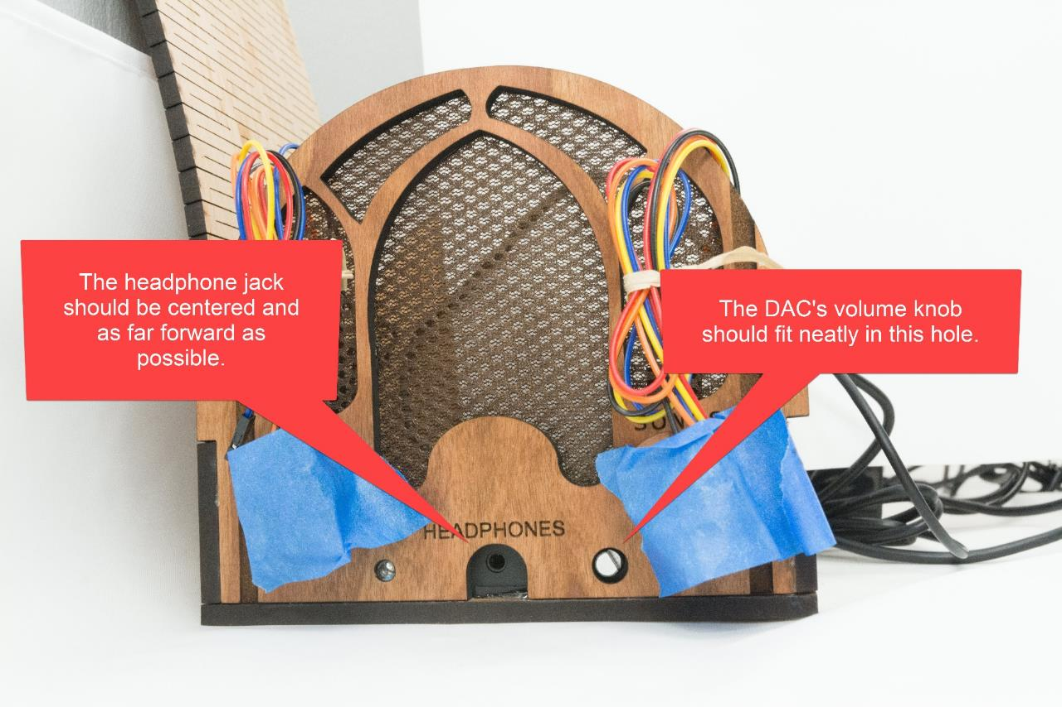

# STEP 27: Plug in DAC & speakers

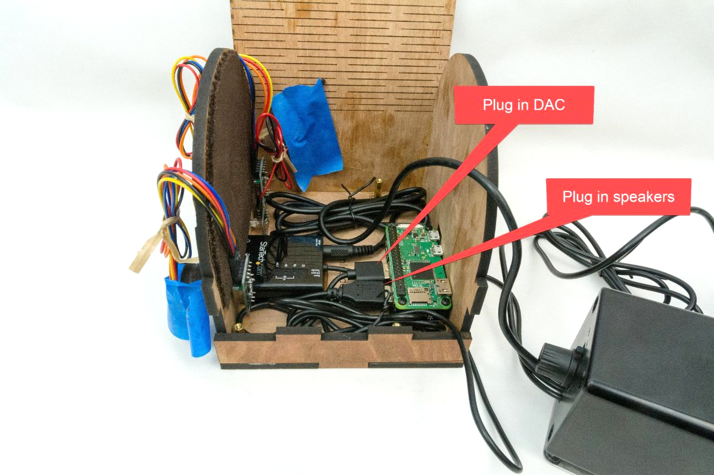

# STEP 28: Wire the songs knob

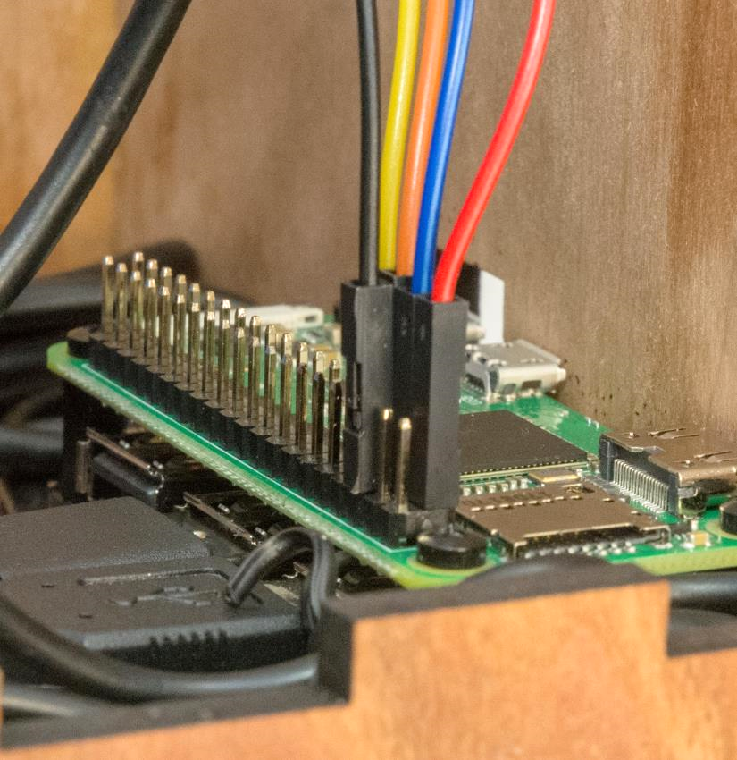

# STEP 29: Wire the LED

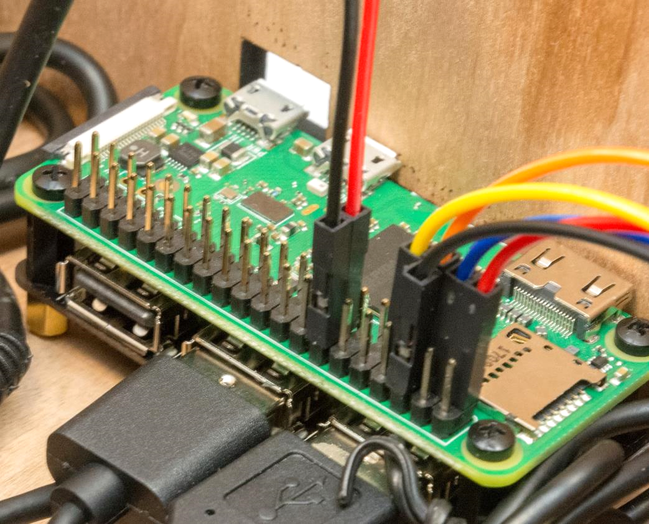

# STEP 30: Wire the volume knob

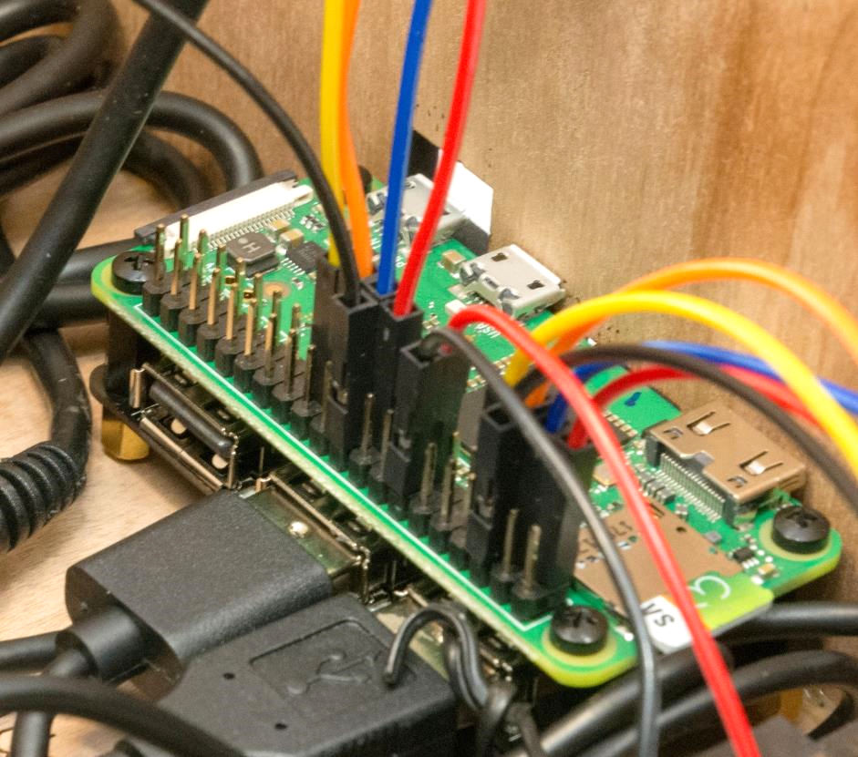

# STEP 31: Check the Pi wiring against this diagram



# STEP 32: Test it

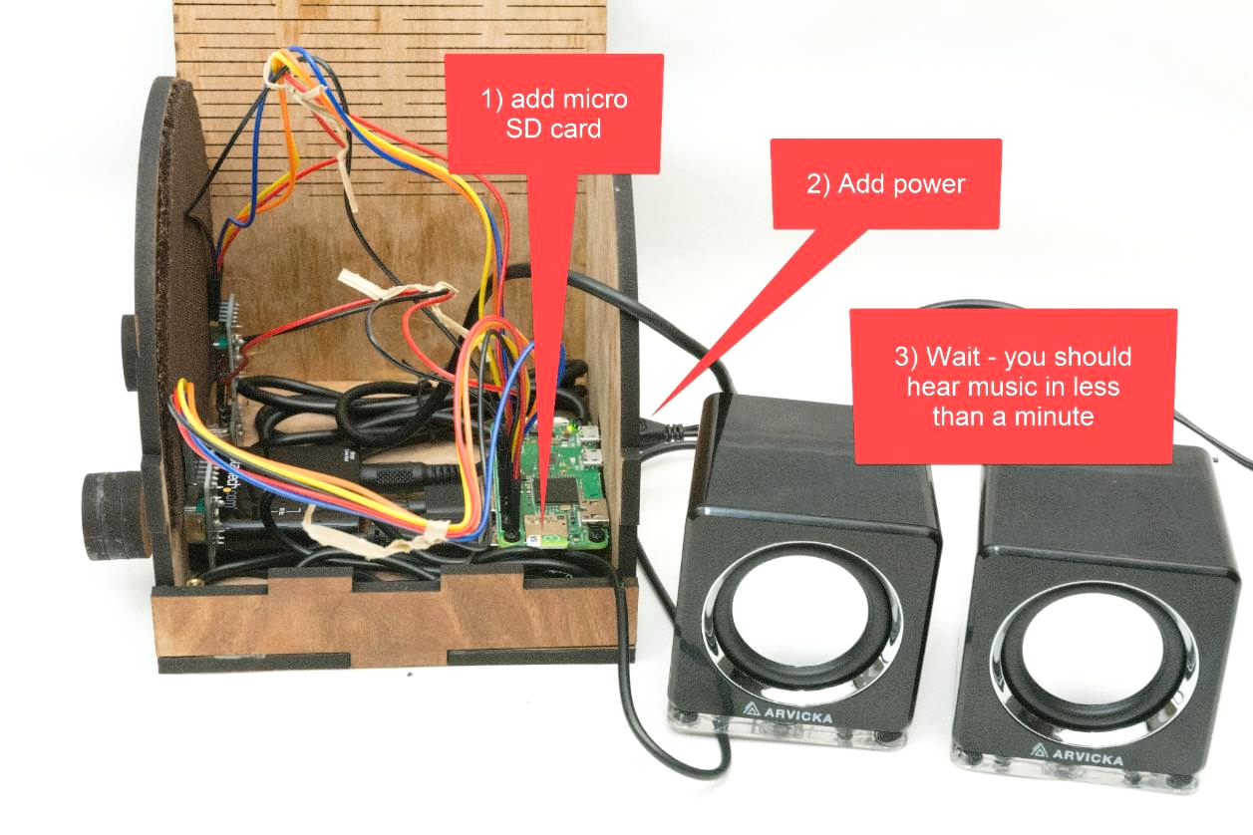

# STEP 33: Test knobs & fix if needed

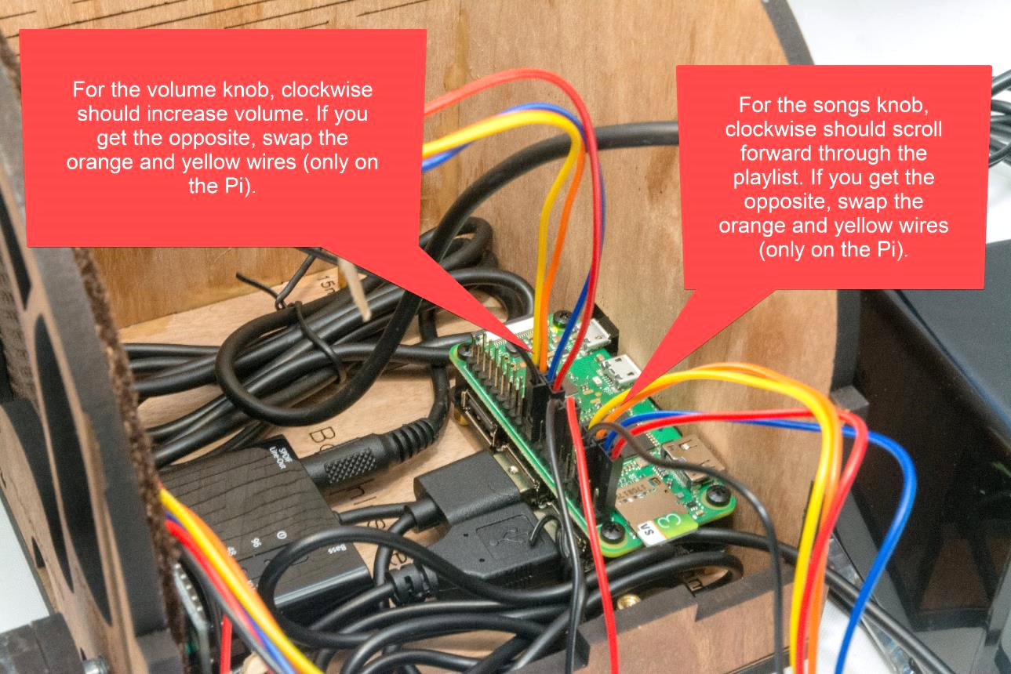

# STEP 34: Put the 2nd floor back on

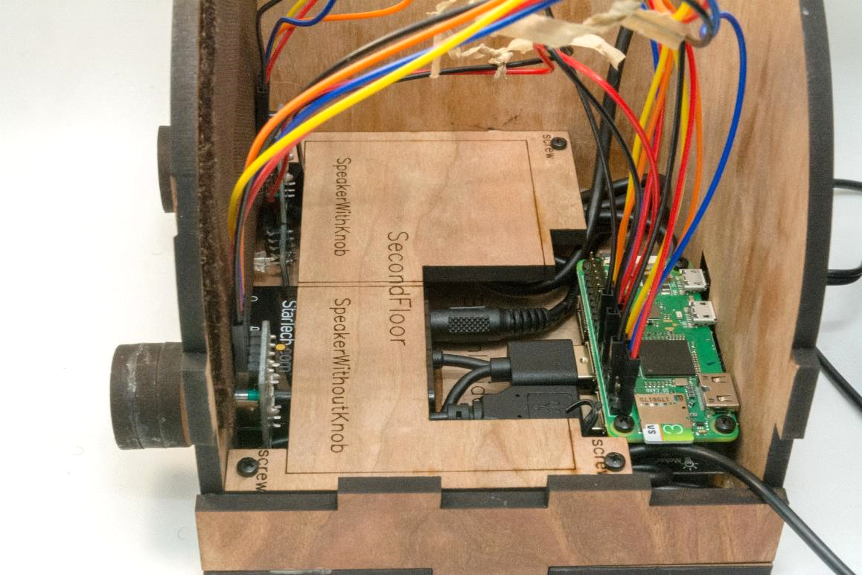

# STEP 35: Add adhesive for speakers

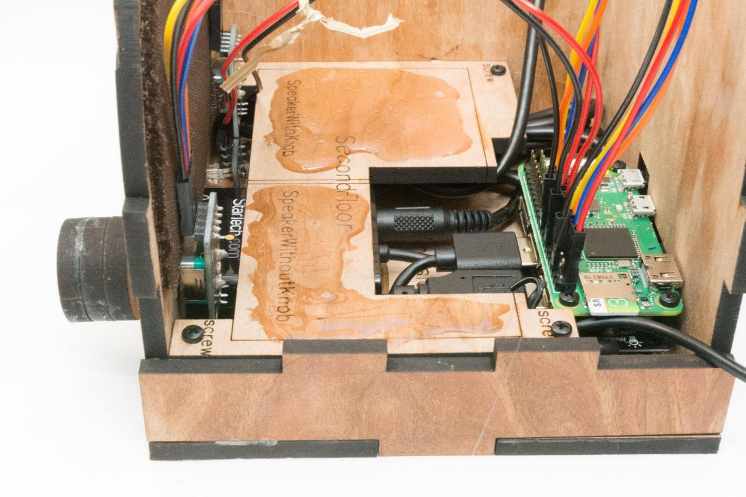

# STEP 36: Place the speaker that doesn’t have a knob

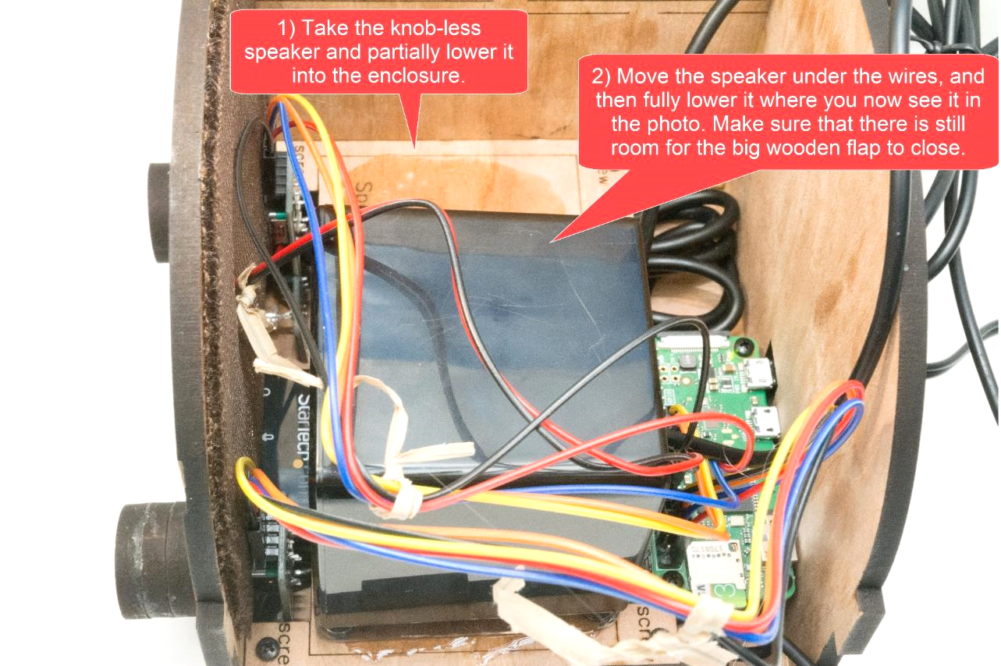

# STEP 37: Place the speaker that does have a knob

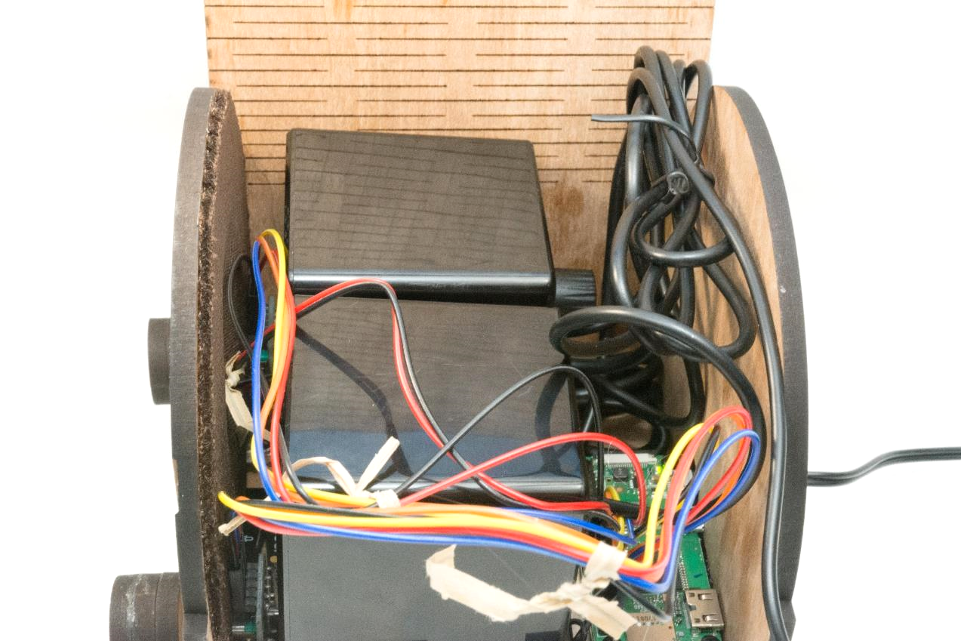

# STEP 38: Make sure that the case closes

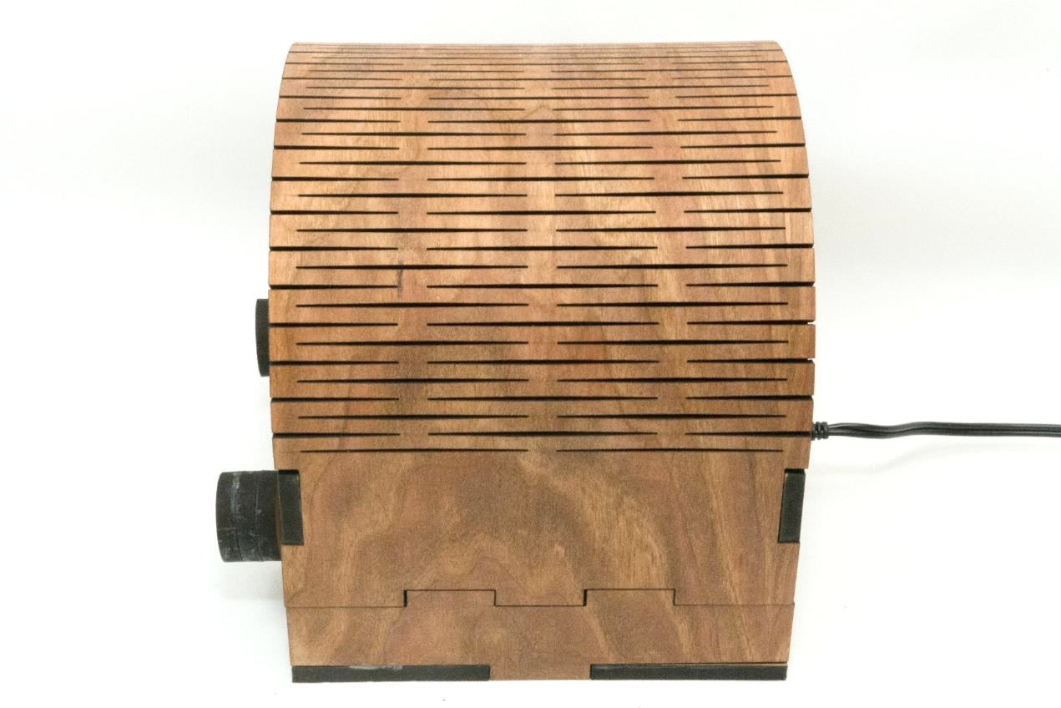

# STEP 39: If needed, tighten the clasp

If the clasp is a bit loose, very slightly increase the size of the tabs by applying a thin layer of glue and allowing to dry before re-latching. It’s a friction clasp, so you are essentially adding more static friction – slightly thicker tabs can mean much more static friction. The photos below are from a different case, but you’ll get the idea.

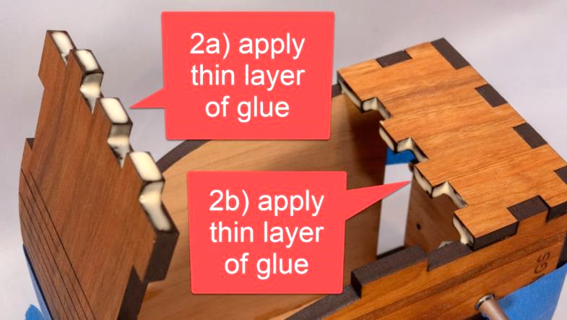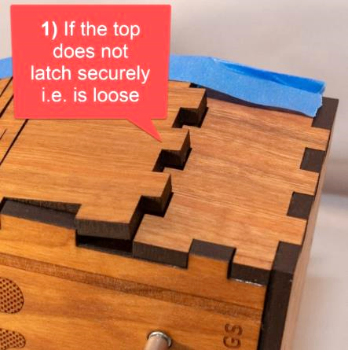

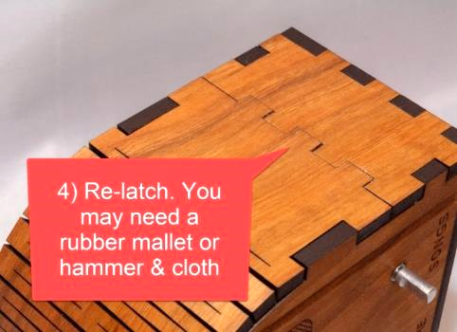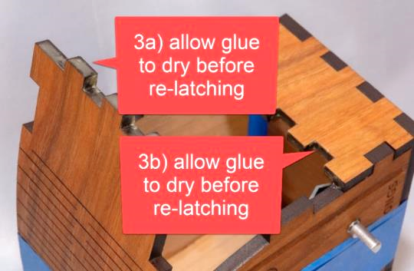

# STEP 40: Add round dimming stickers

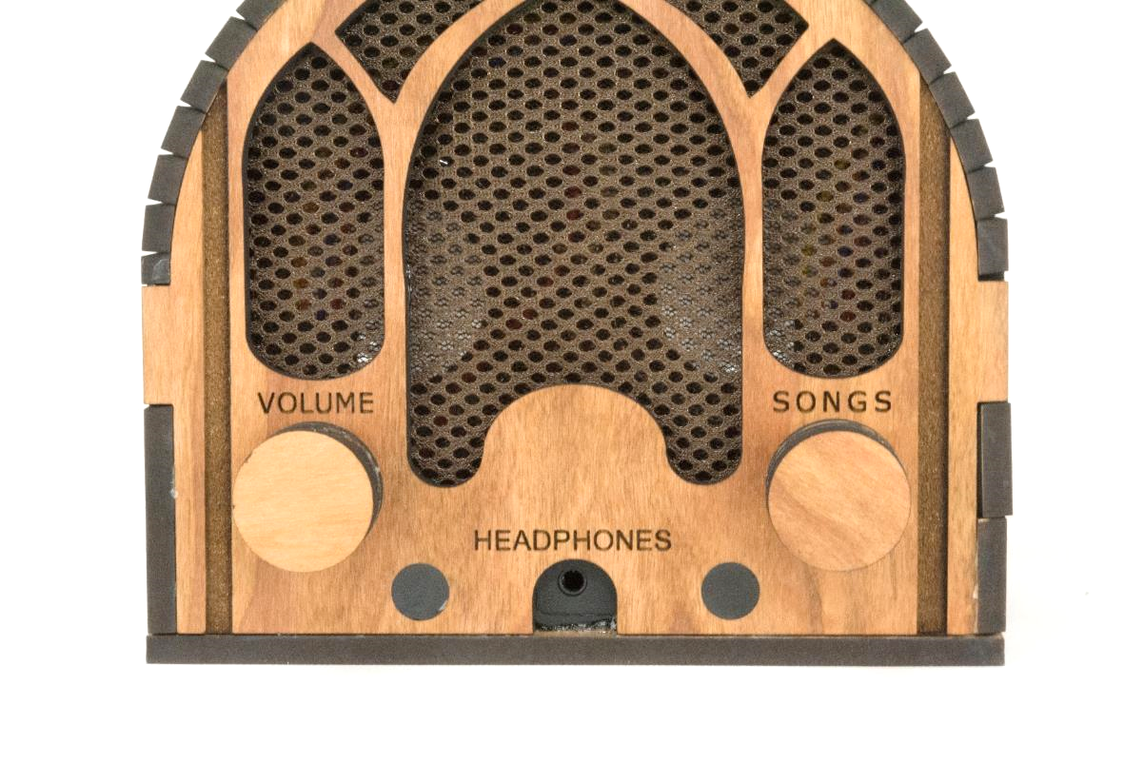

# STEP 41: Test it

|  |  |
| --- | --- |
| **Test** | **Description & Expectation** |
| Light 30sec after power on | Give it power, after 20-30 seconds, the LED should turn on (green) and music should start playing a few seconds later. |
| Change song | Turn the songs knob. If you go forward and backward through the song list as expected, then all is well. |
| Change volume | Turn the volume knob. If the volume goes up and down as expected, then all is well. |
| Pause | Tap the volume knob, song should pause. Tap the songs knob, this should also pause the song. |
| Unpause | Tap a knob |

# STEP 42: Tape the instructions to the bottom

Print this page and tape the instructions in the box below to the bottom of your new Dementia Friendly Music Player:

|  |
| --- |
| **To create personalized music**  **Organize the music on your computer**  One folder per album. Use MP3 files, must have .mp3 file extension. Or iTunes files (.m4a). Or FLAC files (.flac). Optionally, use folder names prefixes to specify the play order e.g. A_, B_  **Copy the music to the USB thumb drive**   1. https://images-na.ssl-images-amazon.com/images/I/71cTRglrgcL._SL1500_.jpgUnplug your Dementia Friendly Music Player. 2. Remove the USB thumb drive and place in your computer. 3. Copy music files from your computer to the USB thumb drive. 4. Put the USB thumb drive back in the player. 5. Plug in your player. |

# STEP 43: Done!

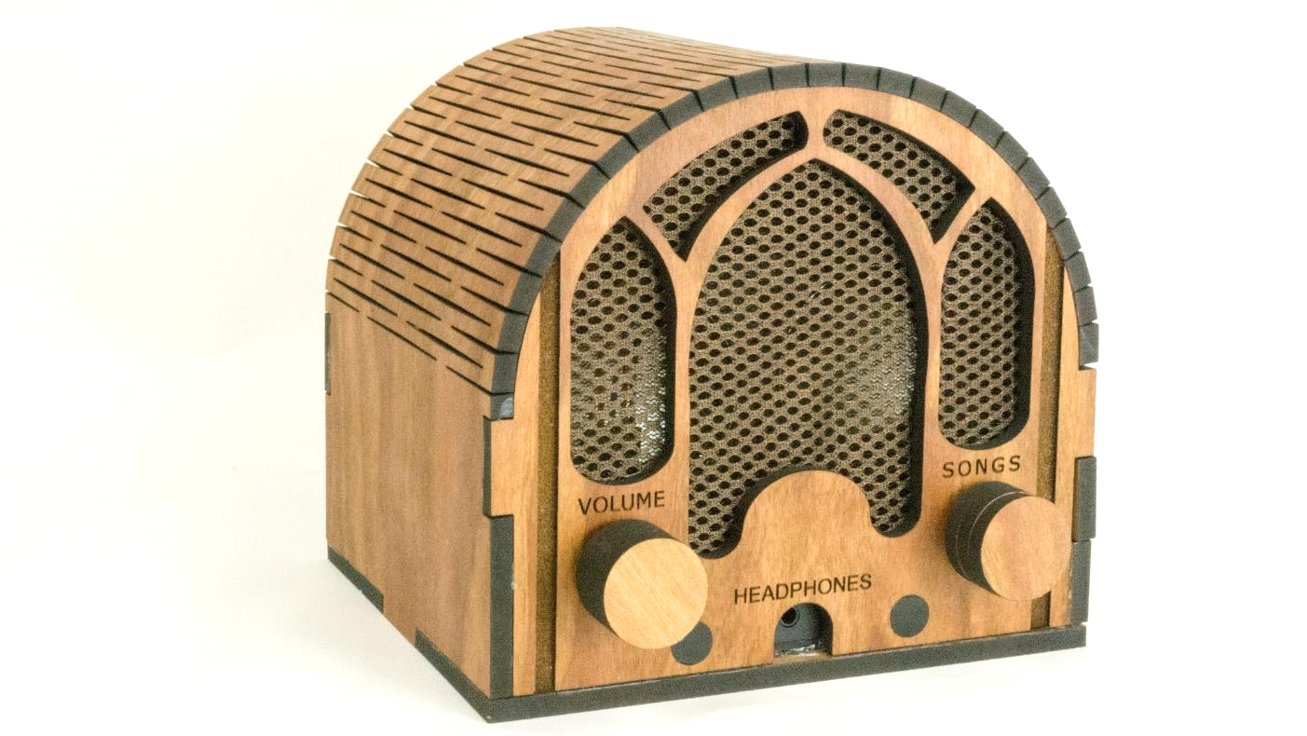

# Appendix 1: Building 10+ at a time

Assumptions:

* You want to build 10 or more units at a time
* You are planning this far enough in advance (6 weeks or more) that you can order some of the parts directly from China
* You are working with a maker space where you can do your own laser cutting & wood finishing (if not, see below)
* If laser cutting yourself, I’m assuming that you will use 5.2mm cherry MDF wood:
  + Looks great
  + Is commonly available
  + Laser cuts well
  + At my supplier, a 4’x8’ sheet is $55, and you can make as many as 12 cases from it
  + Be sure to use the matching laser cutting file from [github](https://github.com/rosswesleyporter/dqmusicbox/tree/master/case/deluxe_model)

|  |  |  |  |  |  |  |
| --- | --- | --- | --- | --- | --- | --- |
| # units to make | 10 |  |  |  |  |  |
|  |  |  |  |  |  |  |
| **Item** | **Supplier** | **Quan** | **Each** | **Total** | **Per unit** | **Notes** |
| Cherry case | Ponoko | 10 | $25.00 | $250.00 | $25.00 | Or order 10+ from Ponoko for @$51.21 |
| [Raspberry Pi Zero WH](https://www.adafruit.com/product/3708) | Adafruit | 10 | $14.00 | $140.00 | $14.00 |  |
| [power supply: 5V 3A, micro-USB](https://www.adafruit.com/product/1995) | Adafruit | 10 | $7.50 | $75.00 | $7.50 |  |
| [USB hub HAT for Pi Zero](https://www.amazon.com/gp/product/B01IT1TLFQ/ref=oh_aui_detailpage_o01_s00?ie=UTF8&psc=1) | Amazon | 10 | $13.99 | $139.90 | $13.99 |  |
| [USB DAC](https://www.amazon.com/gp/product/B00KGK5I38/ref=ox_sc_saved_title_3?smid=ATVPDKIKX0DER&psc=1) | Amazon | 10 | $22.99 | $229.90 | $22.99 |  |
| [M2.5x6mm + 6mm standoffs (50 pieces)](https://www.aliexpress.com/item/32968818335.html?spm=a2g0o.productlist.0.0.6fa03331H4rbn0&algo_pvid=da1db8fd-4357-4d48-a377-a7e7c911e859&algo_expid=da1db8fd-4357-4d48-a377-a7e7c911e859-1&btsid=0ab50f6215840728711114085e2a01&ws_ab_test=searchweb0_0,searchweb201602_,searchweb201603_) | Ali Express | 2 | $2.43 | $4.86 | $0.49 |  |
| [M2.5x15mm + 6mm standoffs (50 pieces)](https://www.aliexpress.com/item/32968818335.html?spm=a2g0o.productlist.0.0.6fa03331H4rbn0&algo_pvid=da1db8fd-4357-4d48-a377-a7e7c911e859&algo_expid=da1db8fd-4357-4d48-a377-a7e7c911e859-1&btsid=0ab50f6215840728711114085e2a01&ws_ab_test=searchweb0_0,searchweb201602_,searchweb201603_) | Ali Express | 1 | $3.49 | $3.49 | $0.35 |  |
| [M2.5 screws length=10mm ThreadPitch=0.45](https://www.amazon.com/Machine-Finish-Phillips-M2-5-0-45-Threaded/dp/B00F33S93E/ref=sr_1_22?rps=1&ie=UTF8&qid=1544398707&sr=8-22&keywords=M2.5+screws+10mm&refinements=p_85%3A2470955011) | Amazon | 1 | $6.72 | $6.72 | $0.67 |  |
| [16GB micro SD card](https://www.amazon.com/Kingston-16GB-microSDHC-Adapter-SDCS2/dp/B07YGZHSJS/ref=dp_ob_title_ce?th=1) | Amazon | 10 | $4.95 | $49.50 | $4.95 |  |
| [USB thumb drive](https://www.amazon.com/gp/product/B077Y149DL/ref=ppx_yo_dt_b_search_asin_title?ie=UTF8&psc=1) | Amazon | 10 | $6.34 | $63.40 | $6.34 |  |
| [Arvicka speakers](https://www.amazon.com/gp/product/B01KC7WGQQ/ref=oh_aui_search_detailpage?ie=UTF8&psc=1) | Amazon | 10 | $19.99 | $199.90 | $19.99 |  |
| [Speaker cloth (large cloth)](https://www.amazon.com/gp/product/B01HMBKQNA/ref=oh_aui_search_detailpage?ie=UTF8&psc=1) | Amazon | 1 | $9.99 | $9.99 | $1.00 |  |
| [Light dimming stickers](https://www.amazon.com/dp/B00CLVEQCO/ref=dp_prsubs_3) | Amazon | 1 | $5.69 | $5.69 | $0.57 |  |
| [E6000 adhesive](https://www.amazon.com/E6000-237039-Multipurpose-Adhesive-Black/dp/B00BSB2R7O/ref=sr_1_5?keywords=E6000&qid=1580662690&sr=8-5) | Amazon | 1 | $10.99 | $10.99 | $1.10 |  |
| [KY-040 rotary encoders (knobs)](https://www.aliexpress.com/item/599712551.html?spm=a2g0o.productlist.0.0.e62e585aMTYzjg&algo_pvid=f1759f37-1668-4260-a1ec-19fa8f3121f1&algo_expid=f1759f37-1668-4260-a1ec-19fa8f3121f1-3&btsid=0ab6f82215868356579722627e4fa1&ws_ab_test=searchweb0_0,searchweb201602_,searchweb201603_) | Ali Express | 20 | $72.00 | $11.00 | $1.10 |  |
| [Female-female jumper wires 30cm](https://www.aliexpress.com/item/32987024879.html?spm=a2g0o.productlist.0.0.55b3783bZgtk65&algo_pvid=fea6cbe1-eec0-4e64-bc8b-0a2ea3f90331&algo_expid=fea6cbe1-eec0-4e64-bc8b-0a2ea3f90331-0&btsid=0ab50f4415840741929443415e70c3&ws_ab_test=searchweb0_0,searchweb201602_,searchweb201603_) | Ali Express | 10 | $1.24 | $12.40 | $1.24 |  |
| [KY-016 indicator LED (10 pieces)](https://www.aliexpress.com/item/32955003054.html?spm=a2g0s.9042311.0.0.6b164c4d50jzDO) | Ali Express | 1 | $1.92 | $1.92 | $0.19 |  |
| [Sticky back rubber feet (100 pieces)](https://www.aliexpress.com/item/4000157727846.html?spm=a2g0o.productlist.0.0.844d376chGZHYJ&algo_pvid=f5f5fcdc-bb29-46e8-acd9-2cf392ad2bfa&algo_expid=f5f5fcdc-bb29-46e8-acd9-2cf392ad2bfa-3&btsid=0ab6d69515849159949164166e32c7&ws_ab_test=searchweb0_0,searchweb201602_,searchweb201603_) | Ali Express | 1 | $1.17 | $1.17 | $0.12 | Only needed for wood < 6mm thick |
|  |  |  |  |  | **$121.58** | +tax + shipping |